Cloud Database Migration

🌟 Definition
# Source: AI Source: Provided by: [Data Path: Persons Table -> ID Column: 1, Name_En Column: Motasem Essam] -> From: [ChatGPT] on [6/7/2026]
Cloud Database Migration is the process of moving a database from an on-premises environment, local server, or another database platform to a cloud-based database service.
The migration may involve:
- Database schema
- Data
- Tables
- Indexes
- Views
- Stored procedures
- Database configurations

🎯 Purpose
# Source: AI Source: Provided by: [Data Path: Persons Table -> ID Column: 1, Name_En Column: Motasem Essam] -> From: [ChatGPT] on [6/7/2026]
Cloud database migration is performed to:
- Reduce infrastructure costs
- Improve scalability
- Improve availability
- Simplify database management
- Increase disaster recovery capabilities
- Support cloud-native applications

🧠 Simple Definition
# Source: AI Source: Provided by: [Data Path: Persons Table -> ID Column: 1, Name_En Column: Motasem Essam] -> From: [ChatGPT] on [6/7/2026]
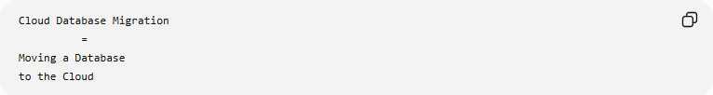
Cloud Database Migration
=
Moving a Database
to the Cloud

📚 What Gets Migrated?
# Source: AI Source: Provided by: [Data Path: Persons Table -> ID Column: 1, Name_En Column: Motasem Essam] -> From: [ChatGPT] on [6/7/2026]
A cloud migration may move:
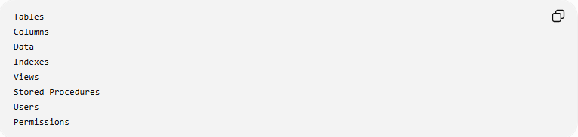
Tables
Columns
Data
Indexes
Views
Stored Procedures
Users
Permissions

🔍 Common Cloud Database Migration Scenarios

1️⃣ On-Premises to Cloud
# Source: AI Source: Provided by: [Data Path: Persons Table -> ID Column: 1, Name_En Column: Motasem Essam] -> From: [ChatGPT] on [6/7/2026]
Before
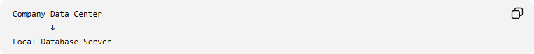
Company Data Center
↓
Local Database Server

After
Cloud Database Service

Example:
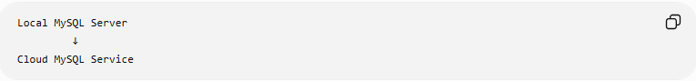
Local MySQL Server
↓
Cloud MySQL Service

2️⃣ Cloud-to-Cloud Migration
# Source: AI Source: Provided by: [Data Path: Persons Table -> ID Column: 1, Name_En Column: Motasem Essam] -> From: [ChatGPT] on [6/7/2026]
Move between cloud providers.
Example
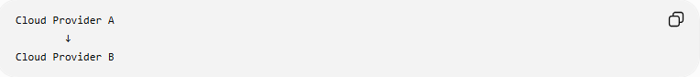
Cloud Provider A
↓
Cloud Provider B

Example:
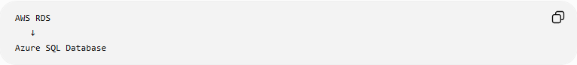
AWS RDS
↓
Azure SQL Database

3️⃣ Hybrid Migration
# Source: AI Source: Provided by: [Data Path: Persons Table -> ID Column: 1, Name_En Column: Motasem Essam] -> From: [ChatGPT] on [6/7/2026]
Part of the database remains local while part moves to the cloud.
Example
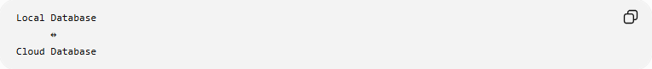
Local Database
↔
Cloud Database

Used when:
Gradual Migration
Compliance Requirements

☁️ Popular Cloud Database Services
# Source: AI Source: Provided by: [Data Path: Persons Table -> ID Column: 1, Name_En Column: Motasem Essam] -> From: [ChatGPT] on [6/7/2026]
Examples include:
- Amazon Web Services RDS
- Amazon Web Services Aurora
- Microsoft SQL Database
- Google Cloud SQL

🛠️ Example Migration
# Source: AI Source: Provided by: [Data Path: Persons Table -> ID Column: 1, Name_En Column: Motasem Essam] -> From: [ChatGPT] on [6/7/2026]
Before
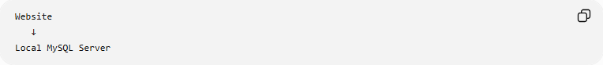
Website
↓
Local MySQL Server

Migration
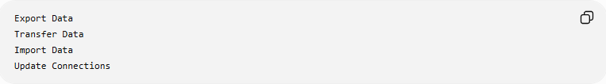
Export Data
Transfer Data
Import Data
Update Connections

After
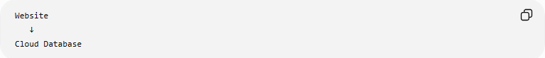
Website
↓
Cloud Database

📦 What Happens During Migration?
# Source: AI Source: Provided by: [Data Path: Persons Table -> ID Column: 1, Name_En Column: Motasem Essam] -> From: [ChatGPT] on [6/7/2026]
Step 1: Schema Migration
Move database structure.
Example:
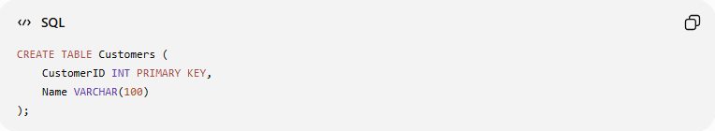
CREATE TABLE Customers (
CustomerID INT PRIMARY KEY,
Name VARCHAR(100)
);

Step 2: Data Migration
Move records.
Example:
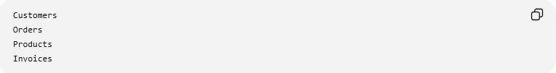
Customers
Orders
Products
Invoices

Step 3: Application Update
Update connection settings.
Before
localhost

After
cloud-database.example.com

🌍 Real-World Example
# Source: AI Source: Provided by: [Data Path: Persons Table -> ID Column: 1, Name_En Column: Motasem Essam] -> From: [ChatGPT] on [6/7/2026]
E-Commerce Website
Current Environment
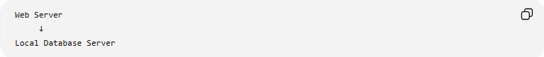
Web Server
↓
Local Database Server
Problems:

Limited Storage
Limited Scalability
Hardware Maintenance

Migration
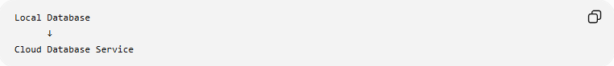
Local Database
↓
Cloud Database Service

New Environment
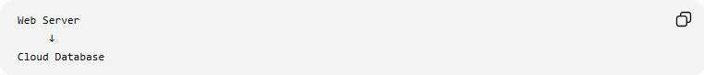
Web Server
↓
Cloud Database
Benefits:
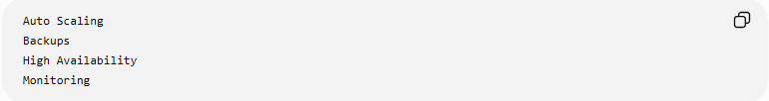
Auto Scaling
Backups
High Availability
Monitoring

🔄 Cloud Database Migration Lifecycle
# Source: AI Source: Provided by: [Data Path: Persons Table -> ID Column: 1, Name_En Column: Motasem Essam] -> From: [ChatGPT] on [6/7/2026]
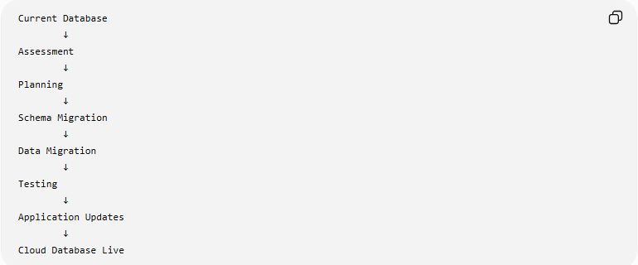
Current Database
↓
Assessment
↓
Planning
↓
Schema Migration
↓
Data Migration
↓
Testing
↓
Application Updates
↓
Cloud Database Live

📊 Migration Strategies
# Source: AI Source: Provided by: [Data Path: Persons Table -> ID Column: 1, Name_En Column: Motasem Essam] -> From: [ChatGPT] on [6/7/2026]
Rehost (Lift and Shift)
Move database with minimal changes.
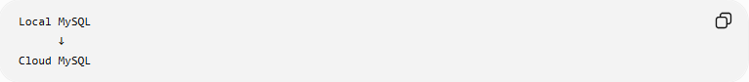
Local MySQL
↓
Cloud MySQL

Replatform
Move while making small improvements.
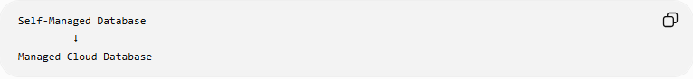
Self-Managed Database
↓
Managed Cloud Database

Refactor
Redesign database architecture.
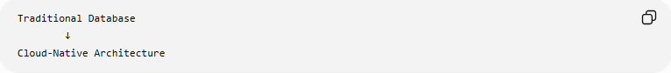
Traditional Database
↓
Cloud-Native Architecture

⚠️ Common Challenges
# Source: AI Source: Provided by: [Data Path: Persons Table -> ID Column: 1, Name_En Column: Motasem Essam] -> From: [ChatGPT] on [6/7/2026]
Data Transfer Time
Large databases may require:

Hours
Days
Weeks
to migrate.

Downtime
Applications may need temporary maintenance windows.

Security
Must protect:
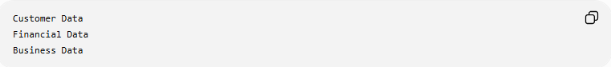
Customer Data
Financial Data
Business Data
during migration.

Compatibility Issues
Different cloud services may support features differently.

Network Bandwidth
Large transfers can be slow.

✅ Benefits of Cloud Database Migration
# Source: AI Source: Provided by: [Data Path: Persons Table -> ID Column: 1, Name_En Column: Motasem Essam] -> From: [ChatGPT] on [6/7/2026]
Scalability
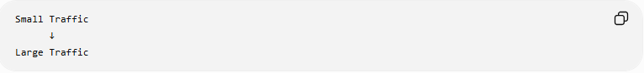
Small Traffic
↓
Large Traffic
without buying new hardware.

High Availability
Automatic Failover
reduces outages.

Automated Backups
Scheduled Backups
without manual intervention.

Reduced Maintenance
Cloud provider manages:
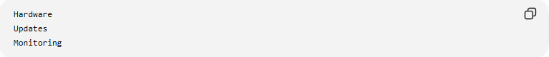
Hardware
Updates
Monitoring

Disaster Recovery
Data Replication
Backup Recovery
improves business continuity.

📊 Cloud Database Migration vs Database Platform Migration
# Source: AI Source: Provided by: [Data Path: Persons Table -> ID Column: 1, Name_En Column: Motasem Essam] -> From: [ChatGPT] on [6/7/2026]
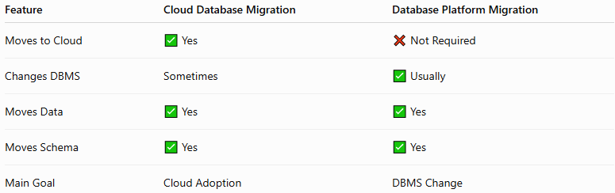
Feature | Cloud Database Migration | Database Platform Migration
Moves to Cloud | ✅ Yes | ❌ Not Required
Changes DBMS | Sometimes | ✅ Usually
Moves Data | ✅ Yes | ✅ Yes
Moves Schema | ✅ Yes | ✅ Yes
Main Goal | Cloud Adoption | DBMS Change

Cloud Migration Example
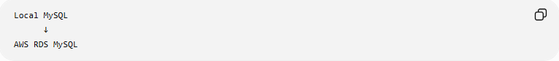
Local MySQL
↓
AWS RDS MySQL
Same DBMS, new environment.

Platform Migration Example
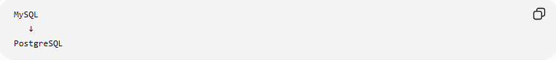
MySQL
↓
PostgreSQL
Different DBMS.

🛠️ Common Cloud Migration Tools
# Source: AI Source: Provided by: [Data Path: Persons Table -> ID Column: 1, Name_En Column: Motasem Essam] -> From: [ChatGPT] on [6/7/2026]
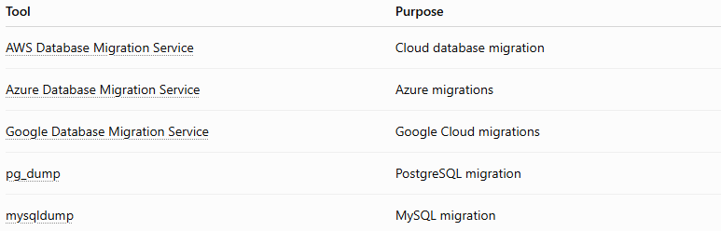
Tool | Purpose
AWS Database Migration Service | Cloud database migration
Azure Database Migration Service | Azure migrations
Google Database Migration Service | Google Cloud migrations
pg_dump | PostgreSQL migration
mysqldump | MySQL migration

🧠 Simple Analogy
# Source: AI Source: Provided by: [Data Path: Persons Table -> ID Column: 1, Name_En Column: Motasem Essam] -> From: [ChatGPT] on [6/7/2026]
Imagine moving your photo collection.
Before
Photos Stored
on Your Computer

Migration

Upload Photos
Transfer Albums
Verify Files

After
Photos Stored
in Cloud Storage
You still have the same photos, but they are now stored and managed in the cloud.
Cloud database migration works the same way:
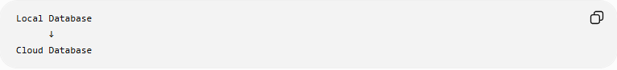
Local Database
↓
Cloud Database
while preserving structure, data, and functionality.

🧭 Summary
# Source: AI Source: Provided by: [Data Path: Persons Table -> ID Column: 1, Name_En Column: Motasem Essam] -> From: [ChatGPT] on [6/7/2026]
Cloud Database Migration is the process of moving a database from a local server, on-premises environment, or another cloud platform to a cloud-based database service. It includes migrating schemas, data, indexes, users, and configurations. Common approaches include on-premises to cloud, cloud-to-cloud, and hybrid migrations. The primary benefits are scalability, high availability, automated backups, disaster recovery, and reduced infrastructure management.

